Survey monuments
and
Corner records
in
The City of Anaheim

What is a survey monument?
Every permanent marker that is set by a surveyor is called a Monument.

These can be:
PK nail and tag
(Tag is about 1-1/2” in diameter)
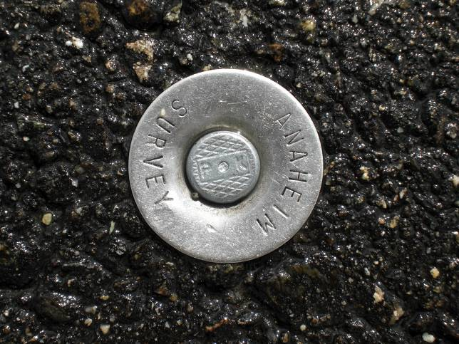

Lead and tack and tag
(Tag is up to ¾” diameter)
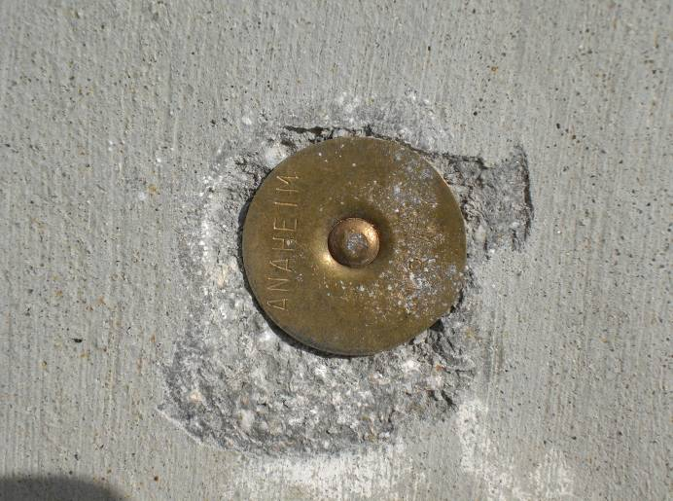
Lead and tack
(Lead up to about 1” diameter)
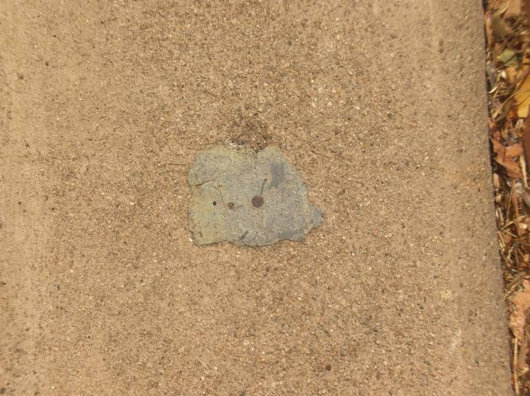
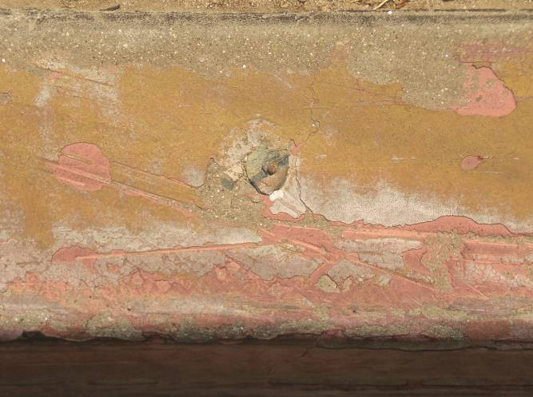

Nail and tag
(Tag is ½” diameter)
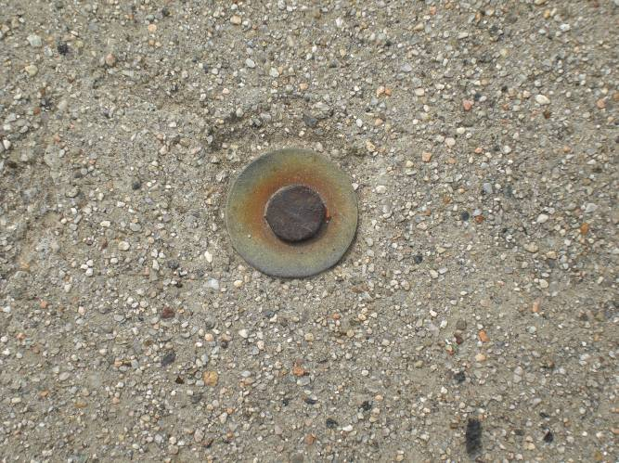

Well monument (about 10” in diameter)
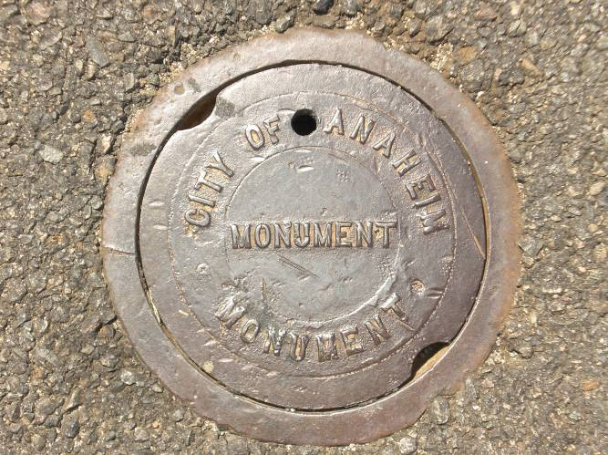

Chiseled plus (before and after highlighting)
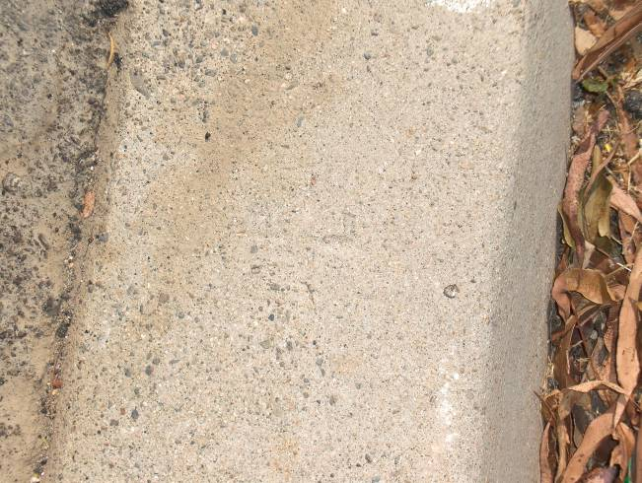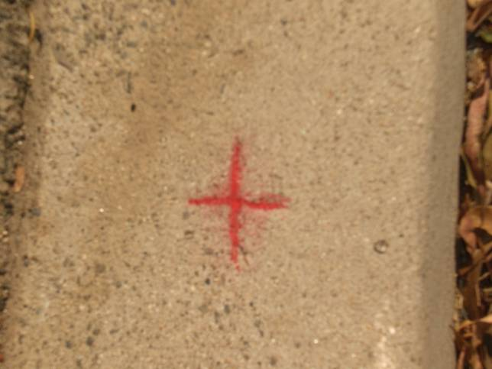

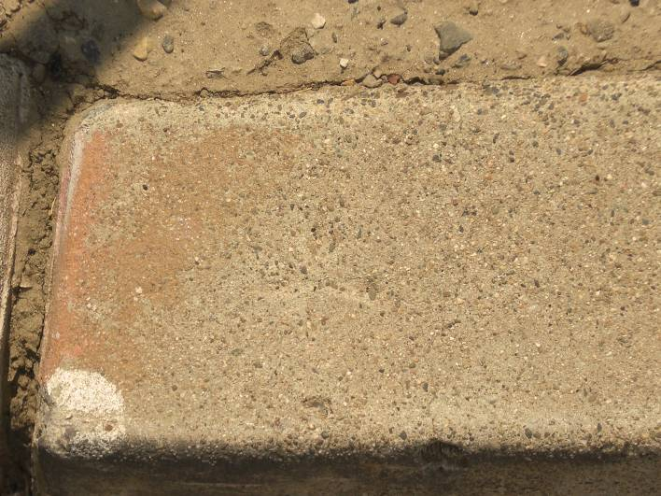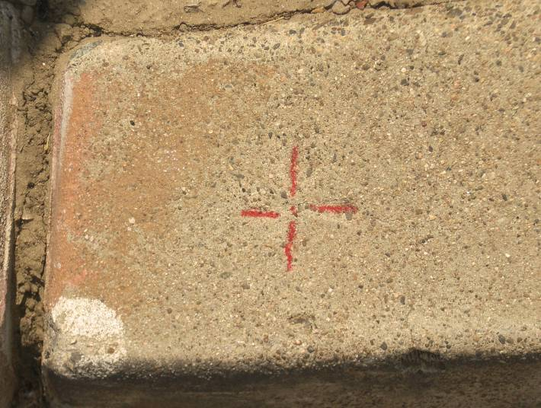
Gear spike and tag
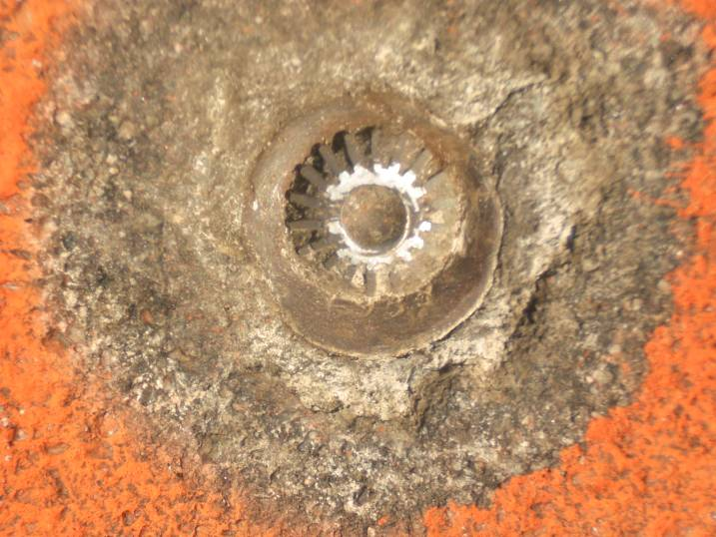
BenchMark
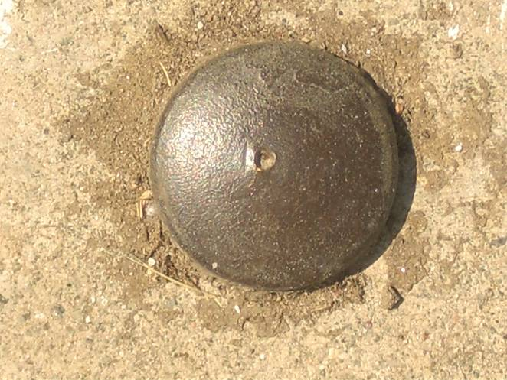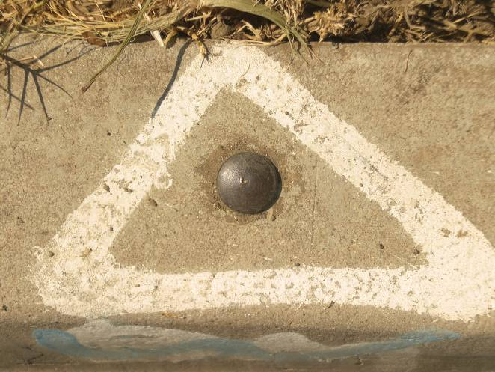

Ramset nail
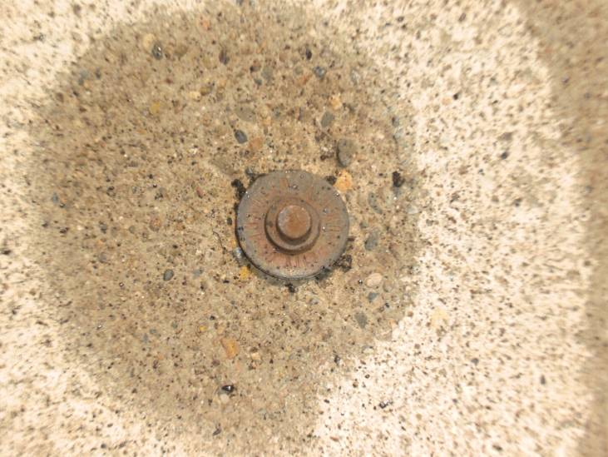

Iron Pipe (1” to 2” diameter)
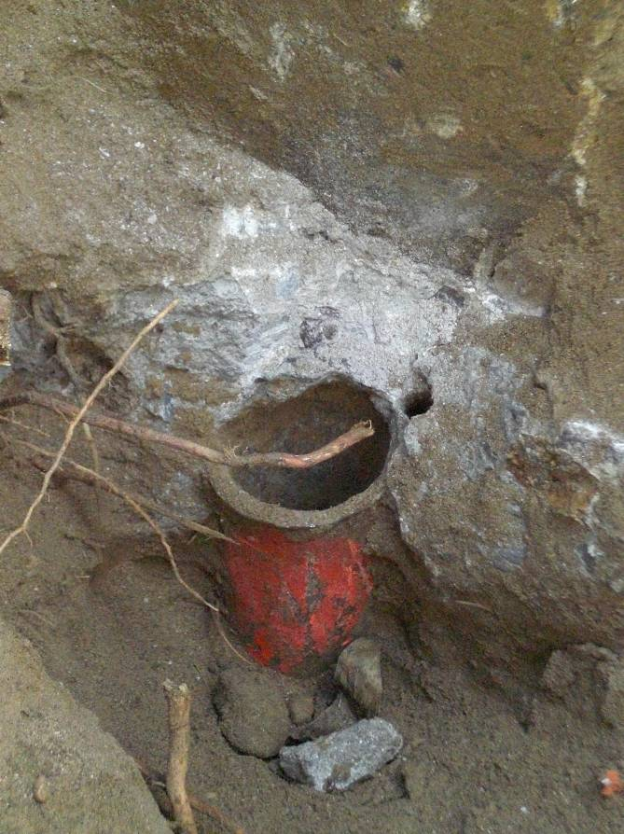
Where do you find them?

What are monuments used for?
Monuments found in the street control the legal centerline of the street. They are the reference points that are shown on recorded maps and are used to define the location of property lines (which means millions of dollars worth of property).
The points found on the curb or in the walk or behind the walk are accessories to the centerline points. They can be used to put back the centerline points should they go missing.
Bench marks are the vertical reference points throughout the City. They are used to control elevations on construction and mapping projects.

What surveyors have to do with them?
State law (the Land Surveyors Act) requires that if a monument is going to be, or has the potential of being removed or disturbed, then a pre-construction corner record for each point shall be filed with the County Surveyor prior to removal, then afterwards the point shall be replaced and a second, Post-construction corner record filed. A corner record is a drawing showing measurements from reference monuments to monuments that will be destroyed, have the potential of being destroyed, or new points that have been set.

What does a corner record look like?
Here are some examples…

What problems are caused when a point is removed and it’s not recorded?
- It’s time consuming and very costly to replace.
- If points on the curb and the street are removed at the same time they are very difficult to replace correctly and then we are required to file a Record of Survey map which is much more involved, can take several months to complete and be very costly.
- It causes difficulties with the County Surveyor’s office, which causes more delay, and therefore more incurred costs.
- It causes delays and extra costs for surveyors performing private surveys. Just think if it was your property being surveyed and there were no points in the ground to be found.
- It’s a violation of State law.

So…
If you find ANY survey points that will be removed or have the potential of being disturbed, please report it to the Survey office at (714) 765-5284 as soon as possible. It takes time to research points and schedule crews to go out and make the necessary measurements and prepare drawings, so the sooner we know the better we can plan.

